**Artificial Intelligence   
Assignment 2 Documentation**

**Group:**Mathew Lawrence ID: 17354272  
Chris Macdonald ID: 1736435

**Operating System:**  
Windows 10

**IDE and Complier:**Visual Studio Code with GCC 9.3.0

**Components of our Fuzzy System**

**Inputs:**

For the design of our fuzzy system, we implemented Yamakawa’s approach. Taking the Pole’s angular position and velocity ( θ and θo ) and the Cart’s horizontal position and velocity ( X and Xo ).   
We combined these together with coefficients to produce the final inputs to the system.

Theta_Emergency = 6 * θ + 0.4 * θo

X_Emergency = 2 * X + 1.2 * Xo

**Fuzzy Rules:**

Using two inputs allowed us to use a single FAMM to compute the result. Our Fuzzy Associative Memory Matrix was as follows…

X Emergency

Theta Emergency

|  |  |  |  |  |  |
| --- | --- | --- | --- | --- | --- |
|  | NL | NS | ZE | PS | PL |
| NL | NL |  | NS |  | PM |
| NS |  | NM |  | PS |  |
| ZE | NM |  | ZE |  | PM |
| PS |  | NS |  | PM |  |
| PL | NM |  | PS |  | PL |

The Force outputs for each of these are:

NL: -150N NM: -60N NS: -4N ZE: 0N PS: 4N PM: 60N PL: 150N

The membership trapezoids were defined as…

**Defuzzification Method**

Defuzzification method used is the Center of Gravity Method given in the Assignment Startup Code.

**Controller Performance:**

Maximum Angles that the controller can handle, starting the cart from x = 1:

-60 degrees, and 35 degrees.

If left undisturbed, Cart will balance indefinitely. Will also retain balance if disturbed in most cases.

**Experiment Results: Control Surface**

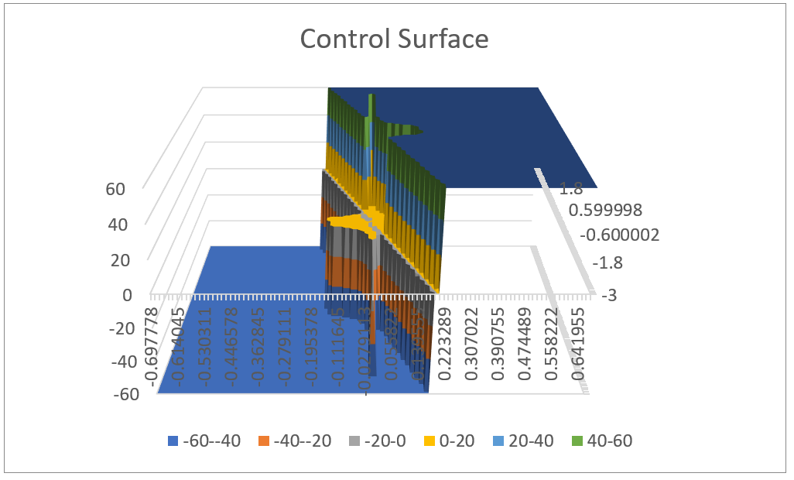

**Additional Notes**

Using Yamakawa’s model of the fuzzy pendulum system allowed for efficient and robust code that required a small number of rules to function, only 13.   
However, we believe this may be a contributing factor in the sharp adjustments the system makes, with less rules to draw upon, the interpolation between membership functions should provide a smoother transition between the two membership outputs.

The Excel Output only displays the forces with very little show for the interpolation between, The data in the text file only showing our POSTIVE and NEGATIVE MEDIUM output with very little change in between.   
But viewing the forces on the simulation…

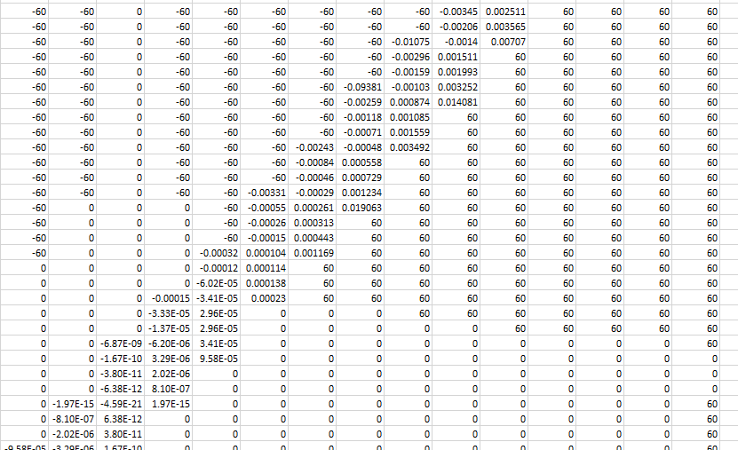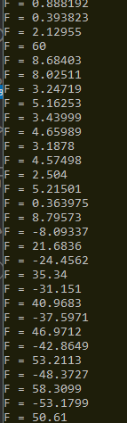

Actual output vs Txt File

Shows a far smoother interpolation, leading us to believe there is an issue with the generate_control_surface() function in our case.